Who is the Hideo Kojima?
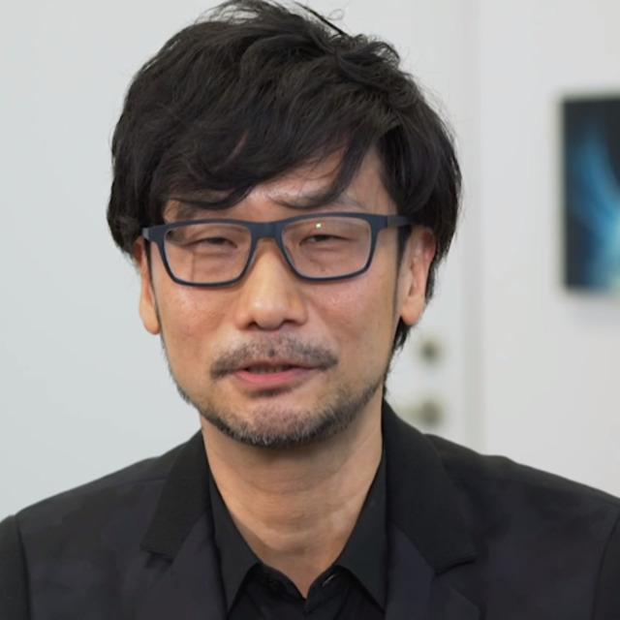

Hideo Kojima is one of the best game designer.He made and is still making significant games those are unique in their category.Also he created several game mechanics those are still used in games.
For example, stealth mechanic is one of the his creations.Morever, he made voice act in some of the games those are produced,directed and designed by himself.He is real god of making games.<3

Biography of Hideo Kojima

Hideo Kojima born August 24, 1963.He is a Japanese video game designer, screenwriter, director, and producer. Regarded as an auter of video games,he is the director of Kojima Productions, which he founded in 2005,and a former vice president of Konami Digital Entertainment.*

Kojima Productions

Kojima Productions is founded by Hideo Kojima.Creation base of some iconic and popular games.
Some of the this games:

- Metal Gear Solid 3 (2005,PS2,PS3,Xbox)**
- Metal Gear Solid 4 (2008,PS3)**
- Metal Gear Solid Portable Ops (2006,PSP)**
- Metal Gear Solid V : Phantom Pain (2015,Windows,PS4,PS4,Xbox One)**
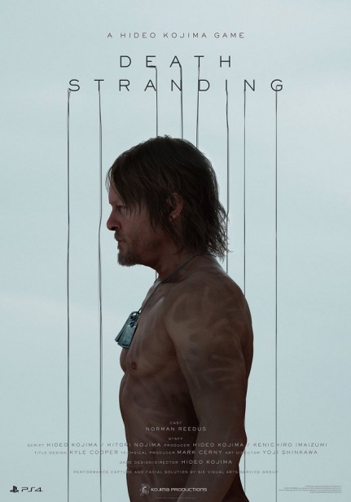
- Death Stranding (Still developing,PS4)**

Metal Gear Series


Metal Gear is longest series that made by Hideo Kojima.Also series has 31 games pusblished in different platforms.First game was published at 1987 and last game published at 2015.I think last game will stay like that forever. Because,Kojima leaved Konami Entertainment and it is not nice way for leaving.Moreover this game is first stealth game and this mechanic easily obtained by gamer comminty beacuse it adds more fun into game.

Death Stranding

Death Stranding will be exculusive game for PS4 platform. Hideo Kojima is producer, designer, director of this game. Also many famous actors worked or are working in this project.Game is still under development but it will come soon. Like many gamer who is fan of Kojima,I am waiting this game with huge impatience.Please, Kojima do not fail us.

